PRODUCTION OF METALIC LANTHANUM FROM ITS OXIDE FORM VIA MOLTEN SALT ELECTROLYSIS

Osman Can Özer¹*, Mehtap Arslan Kaba², Güldem Kartal Şireli², Belma Soydaş Sözer¹, Servet Timur²

1Turkish Energy, Nuclear and Mineral Research Agency (TENMAK), Rare Earth Elements Research Institute (NATEN), Ankara, Turkey
²Istanbul Technical University, Faculty of Chemical and Metallurgical Engineering, Department of Metallurgical and Materials Engineering, Istanbul, Turkey

Keywords: Rare earth elements, Molten salt electrolysis, Rare earth oxides, Molten chloride and fluoride salts

Abstract
Lanthanides, including the elements with the atomic number of 57 to 71, scandium, and yttrium are the seventeen chemically related elements known as rare earth elements (REEs). Despite their misleading name, “rare earth”, these elements are not rare in the Earth’s crust. Instead, the term refers to the challenge of separating and obtaining them in their pure form due to their similar chemical properties. REEs are crucial in a variety of high-technology applications, namely the military, the automobile industry, electrical engineering, optics, catalysts, wind turbines, and other sustainable energy systems, due to their exceptional physical and chemical properties. Because of the growing demand for REEs in functional materials, the recovery of REEs from secondary resources has become critical to the transition to a green economy. The primer REEs extraction process consists of mining, physical beneficiation, chemical treatments, separation, and reduction. In the reduction step, where REEs reduce to metal form, electrolytic methods (molten salt electrolysis) and metallothermic methods are prominently discussed in the open literature. Electrolytic methods can operate continuously and outperform metallothermic techniques in terms of production capacity and controllability, as well as product purity. Nowadays, two types of electrolytes are commonly used in the electrolytic production of REEs: fluoride- and chloride-based molten salts. The main issues with the widely used electrochemical extraction of rare earth oxides in fluoride-based molten electrolytes are lower solubility and lower energy efficiencies, as well as higher emissions of greenhouse gases, such as CO2 and perfluorocarbons, which are extremely harmful to the environment. Given the current limitations of fluoride systems, molten chloride-based electrolytes appear to be a preferable option. To achieve lower melting points (e.g., 650 °C) and higher product purities (i.e., 99%), common chloride electrolytes are composed of RECl3 (RECl3= rare earth chlorides) and additional chlorides, such as NaCl, KCl, BaCl2, and CaCl2. Thus, we concentrated on molten salts based on chlorides containing RECl3. To overcome the low solubility of rare earth oxides in molten chloride salts and toxic oxychloride formations, RECl3 salts were used. RE2O3 was converted to RECl3 in a separate system through chlorination. Furthermore, the need to work in a controlled atmosphere due to REEs high oxygen affinity made the electrolysis cell design critical. As a result, the electrochemical cell was designed and installed, and
the effects of process parameters such as electrolyte composition, temperature, current efficiency, and electrolysis time were investigated systematically. X-ray diffractometry (XRD) and scanning electron microscopy/energy dispersive spectroscopy (SEM/EDS) were used to characterize the produced La. The maximum current efficiency was found to be 73.5%. These obtained results could potentially be implemented during the development of domestic technology for the electrolytic extraction of REEs from Turkey Eskişehir Beylikova REEs ores.

Introduction
The rare earth elements comprise the Group 3 transition elements, scandium and yttrium, as well as the inner transition elements known as lanthanides. The lanthanides include cerium through lutetium [1]–[10]. Scandium and yttrium are chemically similar to lanthanides and often collocated with lanthanides in mineral deposit [11]. The rare earth elements are often divided into the light and heavy rare earth elements as can be seen in Fig 1.1. They show very similar chemical, physical and metallurgical behaviors due to having extremely similar atomic structure, ionic radius and electronic configuration [1], [7], [8], [12].
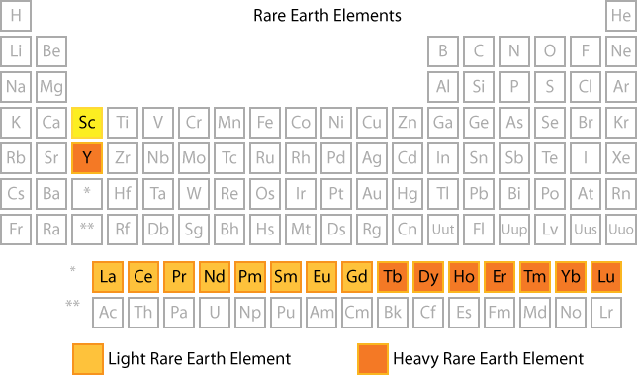
Figure 1.1. The periodic table highlighting rare earth elements [13].

The term ‘Rare Earth’ is not due to their abundance in Earth’s crust, but implies the difficulty of separating from each other selectively by enrichment methods and obtaining them in pure form due to their very similar chemical properties [1]. REEs are extensively utilized in various domains, including automated and liquid catalysts, metallurgy, medical fields, high

technology, clean energy, and military defense systems. Furthermore, they hold an indispensable position in emerging clean technologies such as wind turbines, electric vehicles, energy-efficient lighting, and catalytic converters [14]. Rare earth metallurgy consists of mining, physical beneficiation, chemical treatments, separation and reduction process steps shown in Fig 1.2. In reduction process, where the rare earth metals are produced, metallothermic reduction and molten salt electrolysis are given prominence in the literature [1], [12], [15].
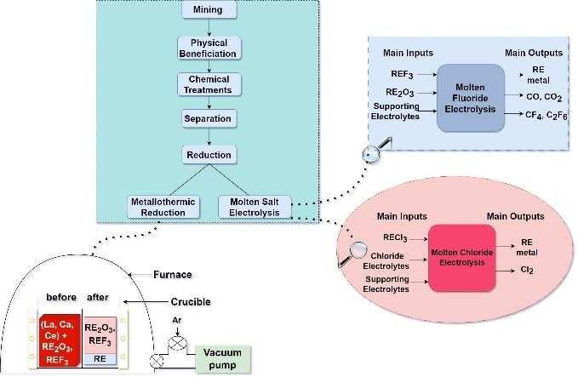
Figure 1.2. Schematic process chain of synthesis of rare earth elements [1], [12], [15].

Metallothermic reduction refers to the reduction of rare earths to metal at high temperatures by active reducing agents such as calcium, lanthanum, and cerium. Molten salt electrolysis is preferred for the synthesis of rare earth metals because metallothermic reduction is a discontinuous process that typically contains higher concentrations of impurities [12]. Currently, there are two main types of electrolytes utilized in the electrolytic production of REEs: fluoride-based and chloride-based molten salts. The molten chloride system utilizes RECl3 as a primary raw material, chosen based on the decomposition potentials of chlorides and the properties of the supporting electrolyte. Conversely, the molten fluoride system employs RE2O3 as the raw material, primarily due to the solubility of RE2O3 in REF3 and the supporting electrolyte. To meet the specific requirements for viscosity, density, conductivity, and melting point of the salt; binary or ternary systems are typically used as supporting electrolytes. Although both systems share the same cathode reaction, involving the reduction of rare earth ions as depicted in Figure 1.3, they differ in terms of the anode reaction.
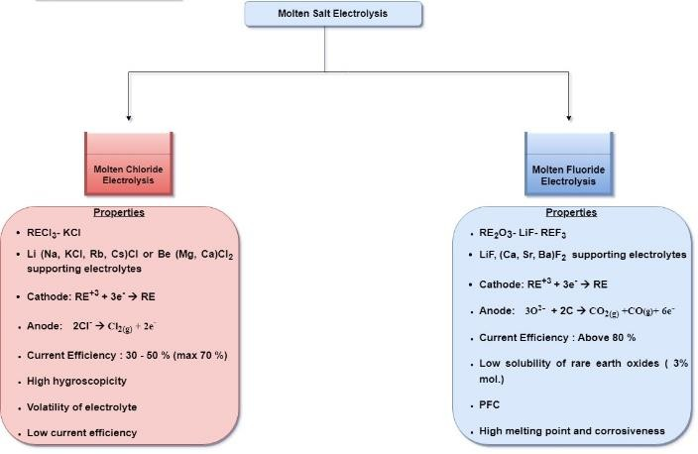
Figure 1.3. Molten salt electrolysis of REEs [16], [17].
The predominant electrochemical extraction of rare earth oxides in fluoride-based molten electrolytes has faced major issues such as lower solubility of rare earth oxides, lower energy efficiencies with higher amounts of greenhouse gas emissions i.e CO2 and perfluorocarbons, which are extremely harmful to environment. Therefore, molten chloride-based electrolytes seem a better choice compared to the current drawbacks of fluoride systems. Thus, we concentrated on molten salts based on chlorides containing RECl3. The design and installation of the electrochemical cell were done and the effects of process parameters such as electrolyte composition, current density, and electrolysis time were investigated in a systematic manner.

Experimental Procedure
The need to work in a controlled atmosphere due to REEs high oxygen affinity made the electrolysis cell design critical. As a result, the electrochemical cell was designed and installed as can be seen in Fig 2.1. To overcome the low solubility of rare earth oxides in molten chloride salts and toxic oxychloride formations, LaCl3 salts were used. Therefore, the first step in the overall process was the conversion of La2O3 to LaCl3 in a separate system through chlorination. Dehydration of LaCl3 was carried out by stepwise heating to 400 ℃ for 48 h in vacuum oven. MeICl2 – MeIICl2 – MeIIICl- MeIVCl (Metal chloride mixture, MexCl2) - MeVIF2 was also dehydrated at 400
℃ for 3 h to remove absorbed moisture. The mixture of anhydrous LaCl3 with MexCl2 - MeVIF2 taken in a required proportion was used as electrolyte for lanthanum metal deposition. A 4.5 cm diameter by 10 cm height graphite crucible with a ceramic sheath that functioned as both an anode and a container was filled with the electrolytic mixture. The resistance furnace with temperature electronic temperature control system was used to heat the cell up to the operating temperature. To ensure the reliability of temperature measurement, the bath temperature was measured using two K- type thermocouples: one from the crucible body and the other from the electrolyte surface, protected by an alumina sheath. After equilibrating the bath for 1 h, electroylsis was carried out for a specific period of time, and after the electrolysis, the deposited lanthanum was analyzed by X-ray diffraction (XRD) and scanning electron microscopy/energy dispersive spectroscopy (SEM/EDS).
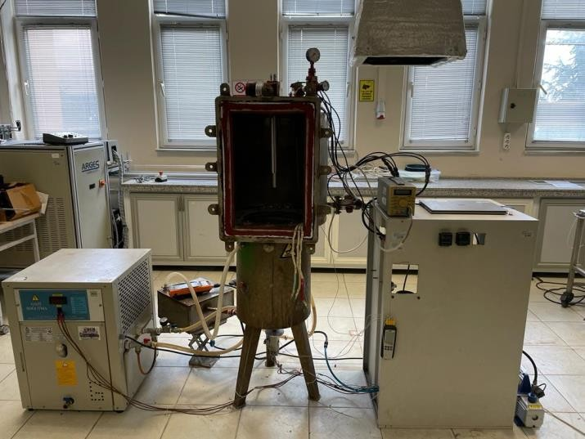
Figure 2.1. Electrochemical cell for REEs molten salt electrolysis

Results and Discussion

  - Electrolytic reaction
The electrochemical cell can be expressed as follows:

C (graphite), Cl2 (g) / LaCl3- MexCl2 - MeVIF2 / La³⁺, C (1) La³⁺ + 3e⁻ La (at cathode, C rod) (2)
3Cl⁻ 3/2Cl2 + 3e⁻ (at anode, graphite) (3)

Characterization of produced metal
Lanthanum metal was characterized by XRD method, and Figure 3.1 shows the image and the XRD pattern of lanthanum metal. All the diffracted peaks well match with their corresponding ICDD Card No: 01-089-2918 and no impurity peaks were found.
However, after 500 mA/cm2, the increase in CCE values in the co-deposition of flux ions due to high-negative potential of flux ions, which reaches the deposition potential of flux ions. The optimum CD for lanthanum deposition is found 500 mA/cm² in MexCl2 - MeVIF2 bath.

3.4. Effect of electrolysis time on the CCE
The effect of electrolysis time on the CCE was examined in MexCl2 - MeVIF2 bath and 500 mA/cm² condition. Figure 3.3 shows the variation of CCE in the electrolysis time range of 60-120 min. After the 90 min, the CCE decreases as a result of the decrease in the migration of La³⁺ ions in the electrolyte due to the decrease in the solubility of LaCl3.

76

y = -0,0232x2 + 3,86x - 85,8
R² = 1
Cathodic current efficiency (%)

57

38

19

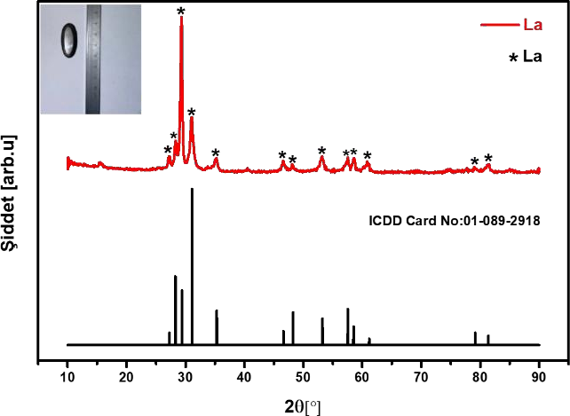
0
60 70 80 90 100 110 120
Electrolysis time (min)
Figure 3.3. Effect of electrolysis time on CCE for La metal in MexCl2 - MeVIF2 bath.

Figure 3.1. XRD pattern of produced lanthanum metal (with the inserted image)

3.3. Effect of current density (CD) on cathodic current efficiency (CCE)
The relationship between CD and CCE was studied for La metal deposition in MexCl2 - MeVIF2 bath. Figure 3.2 shows the variation of CCE in the CD range of 250-750 mA/cm2. With the increasing CD, the kinetic of migration of lanthanide ions increases due to the increase of cathodic potential, thus helps in depositing the lanthanum metal at a greater speed thus increases the CCE.

80

y = -0,0007x² + 0,8072x - 149,7
R² = 1

70
Cathodic current efficiency (%)

60

50

40

30

20

10

0
250 300 350 400 450 500 550 600 650 700 750
Current density (mA/cm²)
Figure 3.2. Effect of current densities on CCE for La metal in MexCl2 - MeVIF2 bath.

Conclusion
In experimental studies, the effects of current density and electrolysis time on the production efficiency of metallic lanthanum by molten salt electrolysis were systematically examined. As a result, the first metallic lanthanum was produced and the maximum current efficiency was found as 73.5% at the current density of 500 mA/cm², in in MexCl2 - MeVIF2 bath in 90 min electrolysis time.

Acknowledgement
This study is coordinated and financially supported by TENMAK NATEN [Project No:A2.H1.P18].

References
- E. Baştürkcü, C. Şavran, S. Timur, and A. Ekrem. Yüce, “Birincil ve İkincil Mineral Kaynaklarından Nadir Toprak Elementlerinin Fiziksel ve Fizikokimyasal Yöntemlerle Üretim Proseslerinin İncelenmesi,” Int. J. Pure Appl. Sci., vol. 7, no. 2, pp. 276–287, 2021.
- S. Briefs and I. N. Earth, The rare earth elements: an introduction, vol. 53, no. 11. 2016.
- G. K. Gupta and N. Krishnamurthy, Extractive metallurgy of rare earths, vol. 37, no. 1. 1992. doi: 10.1179/imr.1992.37.1.197.
- A. R. Jha, Rare earth materials: Properties and applications. 2014.
- P. Kim, A. Anderko, A. Navrotsky, and R. E. Riman, “Trends in structure and thermodynamic properties of normal rare earth carbonates and rare earth hydroxycarbonates,” Minerals, vol. 8, no. 3, 2018
- J. Wang, M. Guo, M. Liu, and X. Wei, “Long-term outlook for global rare earth production,” Resource. Policy, vol. 65, no. January, p. 101569, 2020.
[7] P. Sarfo, “Recovery of Rare Earth Elements By Advanced Processing Technologies,” Montana Tech, 2019.
[8] F. R. Spellman, The Science of Rare Earth Elements. 2022.
[9] G. Theses and A. Gunawan, “Digital Commons @ ontana Tech Thermodynamic Considerations in Molten Salt Electrolysis for Rare Earth Metals,” 2015.
[10] V. Zepf, An Overview of the Usefulness and Strategic Value of Rare Earth Metals. Elsevier Inc., 2015.
[11] D. A. Atwood, The Rare Earth Elements: Fundamentals and Applications. 2012.
[12] H. Liu, Y. Zhang, Y. Luan, H. Yu, and D. Li, “Research progress in preparation and purification of rare earth metals,” Metals (Basel)., vol. 10, no. 10, pp. 1–13, 2020.
[13] J. Lucas, P. Lucas, T. L. Mercier, A. Rollat, and W. Davenport, Rare Earths Rare Earths Production and Use. 2014.
[14] B. Zhou, Z. Li, and C. Chen, “Global potential of rare earth resources and rare earth demand from clean technologies,” Minerals, vol. 7, no. 11, 2017, doi: 10.3390/min7110203.
[15] R. Akolkar, “Perspective—Is Sustainable Electrowinning of Neodymium Metal Achievable?,” J. Electrochem. Soc., 2022.
[16] R. Methods, Encyclopedia of Applied Electrochemistry. 2014.
[17] X. Y. Yan and D. J. Fray, Molten Salt Electrolysis for Sustainable Metals Extraction and Materials Processing – A Review. 2010

