Shielding effect of boron carbide-tungsten carbide-aluminum metal matrix hybrid composite against different type of radiations

Ayhan AKKAS¹, A. Beril TUGRUL², Onur TAZEGUL³

1 Turkish Energy Nuclear and Mineral Research Agency, Nuclear Energy Research Institute, Istanbul, Türkiye
2 Istanbul Technical University, Energy Institute, Nuclear Researches Division, Istanbul, Türkiye
3 Istanbul Technical University, Chemistry & Metallurgical Faculty. Materials Science Div., Istanbul, Türkiye

¹ayhan.akkas@tenmak.gov.tr , ²beril@itu.edu.tr, ³tazegul@itu.edu.tr,

Abstract
The present study examined the shielding effect of composite materials containing varying proportions of aluminum, boron carbide and tungsten carbide compounds against different radiation types. The transmission technique was used to investigate the attenuation properties of the materials against gamma, beta and neutron radiation. The linear and mass attenuation coefficients of the samples were determined by 0.059 MeV (Am-241), 0.662 MeV (Cs-137) and 1.25 MeV (Co-60) energetic gamma rays and Emax = 2.25 MeV energetic beta rays. Furthermore, the total macroscopic cross section (Σ_{T}) was calculated for the materials in the presence of the Pu-Be neutron source. The gamma mass attenuation coefficient values were compared with theoretical values obtained from the XCOM programme code. Calculations of the half-value thickness (HVT) were conducted utilising linear attenuation coefficient and total macroscopic cross-section values. The results demonstrated that an increase in the tungsten carbide content of the materials resulted in an enhancement of the HVTs against gamma and beta radiation from Am-241, Cs-137 and Co-60. Furthermore, an increase in the boron carbide ratio resulted in an enhancement of the HVTs against the Pu-Be neutron source. The findings of this study may prove useful in the selection of effective shielding materials against mixed radiation in nuclear industries.
Keywords: Shielding, tungsten carbide, boron carbide, gamma attenuation, neutron attenuation, beta attenuation.
- Introduction
The general population is exposed to ionising radiation in a variety of ways, both artificially and naturally. One of the most crucial aspects of protection against ionising radiation or radioactive sources is the use of an appropriate shielding material. The selection of an appropriate radiation shielding material is dependent upon the specific characteristics of the material and the energy in question. Radiation shielding materials and components should exhibit high radiation absorption capacity, low density, chemical stability, non-toxicity, non-flammability, good heat transfer behaviour, long-term reliability, and good fabrication properties in nuclear facilities and space research areas. Furthermore, the effective use of a single material is of paramount importance in areas where different types of radiation are present simultaneously, as the utilisation of multiple materials is impractical in volumetric space.
Previously, Al-B₄C composite materials were demonstrated to possess effective thermal neutron shielding properties. However, in the context of gamma radiation with different energies, the same effectiveness was not observed. Consequently, tungsten carbide materials are produced in conjunction with joining Al-B₄C-WC hybrid composite materials.
The application of B₄C is based on the utilisation of its high degree of hardness, abrasive resistance, wear resistance, semiconducting properties and ability to absorb thermal neutrons [9]. Tungsten carbide is sufficiently stable and exhibits minimal change in its properties with the increase in temperature from 300K to 1200-1300K. Moreover, in comparison to carbides of other transition metals, tungsten carbide exhibits a higher Young's modulus, with a value of approximately 700 GPa, which is twice that of other carbides. The coefficient of thermal expansion of WC is approximately 5.5 x 10⁻⁶ K⁻¹, which is half that of the other transition metal carbides [10]. Tungsten carbide is used primarily as a cutting tool and in sports that necessitate the use of a hard material.
In this study, a series of Al-B₄C-WC hybrid composite materials were prepared in different volumetric ratios and their shielding effectiveness against three different types of radiation was measured: gamma radiation, neutron radiation and beta radiation. The results of the radiation transmission experiments revealed the values of the linear attenuation coefficient, mass attenuation coefficient, and half value thickness (HVL) for gamma and beta radiation, as well as the macroscopic cross section and HVL values for neutron radiation. The mass attenuation coefficient values for gamma radiation were compared with the theoretical values obtained from the XCOM programme. Berger and Hubbell developed the XCOM computer program for calculating cross-section and attenuation coefficients for elements, compounds and mixtures for photon energies from 1 keV to 100 keV [11]. The most effective shielding material for the mixed radiation fields studied was selected by comparing the HVL values found.
- Materials and Methods
  - Materials
Aluminum-boron carbide-tungsten carbide composites were produced by hot pressing at 300°C under 100 psi pressure for 10 minutes. The materials were coded according to the percentage of boron carbide and tungsten carbide, and the composites have different proportions of boron carbide and tungsten carbide, as shown in Table 1.

Table 1. The content of the studied composite materials and their properties
Material Code | Al  (Vol %) | B₄C  (Vol %) | WC  (Vol %) | Hardness  (Vickers) | Density ± 0.001  (g/cm³)
Al-1000 | 90 | 10 | - | 38,020 ± 0,249 | 2,622
Al-0505 | 90 | 5 | 5 | 38,948 ± 0,296 | 3,198
Al-0010 | 90 | - | 10 | 38,391 ± 0,175 | 3,716
Al-1005 | 85 | 10 | 5 | 36,893 ± 0,201 | 3,144
Al-0510 | 85 | 5 | 10 | 36,025 ± 0,230 | 3,649
The scanning electron microscope (SEM) and X-ray diffraction views of the composites are shown in Figure 1 and Figure 2 respectively. In the SEM views, boron carbide is black, tungsten carbide is white and aluminum is grey. The distribution of B₄C and WC particles in the aluminum metal matrix is almost homogeneous. XRD patterns of the materials showed that any phases were different from the powder mixture prepared for the pressing stage of the study. These results also indicated that any reaction between the matrix and the additives during the manufacturing process.
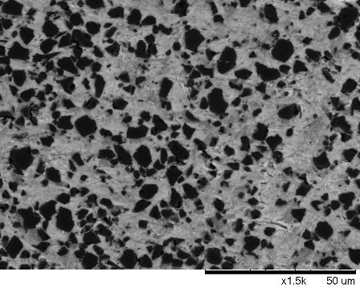 | 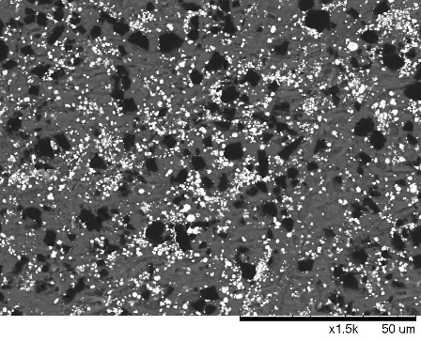 |  | 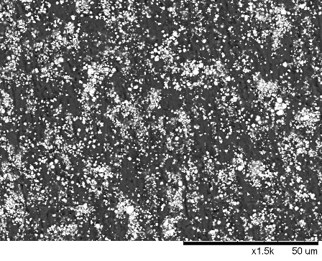
(a) | (b) |  | (c)
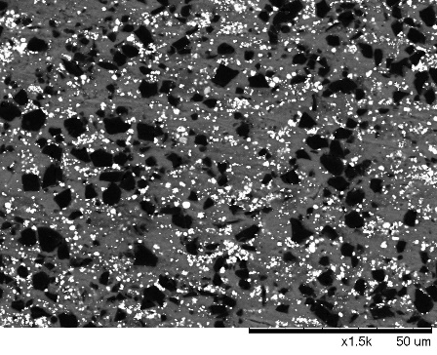 |  | 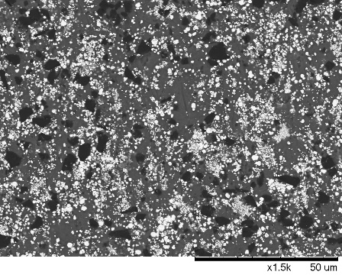
(d) |  | (e)
Figure 1. SEM views of composite materials a) Al-1000 b) Al-0505 c) Al-0010 d) Al-1005 e) Al-0510

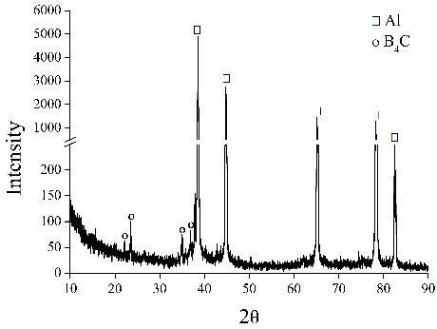 | 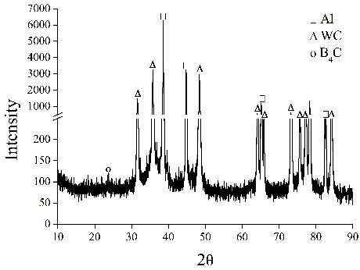 |  | 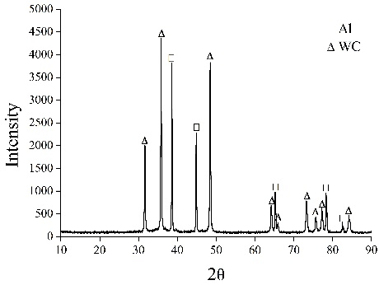
(a) | (b) |  | (c)
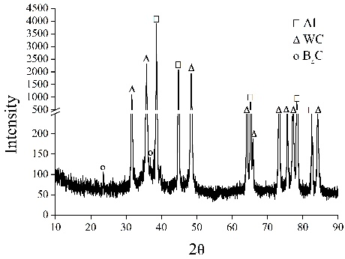 |  | 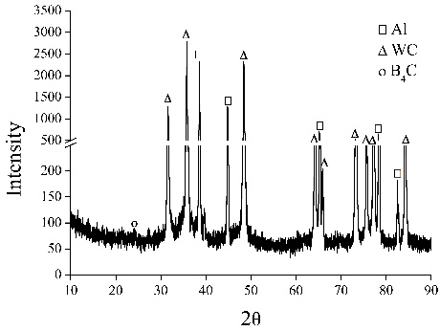
(d) |  | (e)
Figure 2. XRD views of composite materials a) Al-1000 b) Al-0505 c) Al-0010 d) Al-1005 e) Al-0510.
  - Methods
    - Gamma Transmission Experiments
Gamma ray transmission technique in narrow beam geometry based on the measurement of the attenuation of photons of an incident beam absorbed when passing through the materials. Experiments with gamma radiation were carried out using Am-241 at low energy (60 keV), Co-60 at high energy (two peaks at 1.17 and 1.33 MeV, average 1.25 MeV) and Cs-137 at medium energy (662 keV). An NaI scintillation detector was used to detect gamma photons from radioactive sources. The samples were placed between the source and the detector. The detector was shielded with lead blocks to block photons scattered from the detector. The schematic representation of the gamma transmission technique is given in Figure 3.
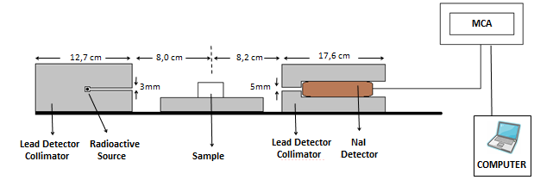
Figure 3. Schematic view of gamma setup.
The linear attenuation coefficients of the composites were calculated using the Beer-Lambert equation. The half-value thickness (HVT) values and mass attenuation coefficients (µm) of the composites were determined at specific gamma energies [12].
Relative intensity-material thickness graphs for Al-0510, Al-1005, Al-1000, Al-0010 and Al-0505 composites against gamma radioisotope sources are shown in Figure 4 to Figure 6, respectively.
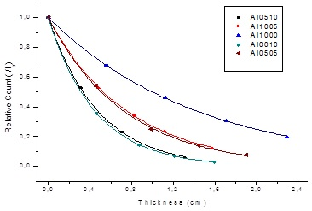
Figure 4. Relative intensity-thickness graphs for materials against Am-241 gamma source.

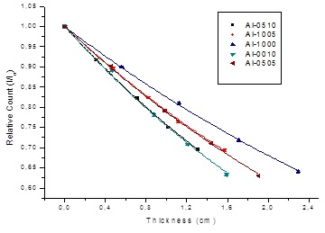
Figure 5. Relative intensity-thickness graphs for materials against Cs-137 gamma source.
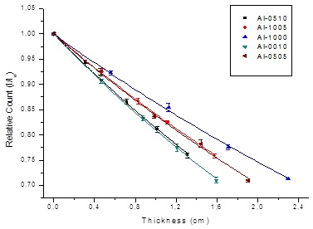
Figure 6. Relative intensity-thickness graphs for materials against Co-60 gamma source.
    - Neutron Transmission Experiments
Experiments were conducted utilising the Pu-Be neutron source within the Pu-Be neutron howitzer (NH-3), manufactured by the Nuclear Chicago Corporation. The Pu-Be neutron source has an activity of 5 Ci, a neutron flux of 10⁶ n/cm²·s, and an average neutron energy of 5 MeV (Farr, 1966). ³He detector was used for the purpose of neutron detection and surrounded by paraffin colimators except for the facing direction. Paraffin wax (2.5 cm thick) was used to slow down the neutron energies [13] (Gordous, 1967).
The total macroscopic cross sections (Σ_{T}) were calculated from the graphs using the computer program Origin 8.
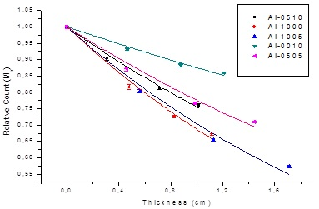
Figure 7. Relative intensity-thickness graphs for composite materials against Pu-Be neutron source.
    - Beta Transmission Experiments
Beta experiments were conducted using a narrow beam geometry. In these experiments, a pure beta source, Sr/Y-90, was used. The maximum beta energy emitted by the radioactive source was 2.28 megavolt electron-volt (MeV). The electron beam emanating from the radioactive source material was collimated using plexiglas, with a thickness of 5 cm. In the experiments, a Thermo AB100 scintillation detector was used. The distance between the detector and the source was 2 cm. The lead material was positioned between the detector and the source in order to prevent X-rays, which are generated by the interaction of electrons and material, from reaching the detector. The configuration of the beta experiment is illustrated schematically in Figure 8.
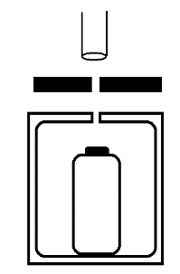
Sr-90 Beta Source
Plexiglass protector and collimator
Lead collimator
Detector
2 cm

Figure 8. Schematic view of beta setup.
The experimental interpolation method was used to eliminate the influence of X-rays on the beta experimental results. This method was utilized to remove the effect of X-rays in the beta experimental results [14]. According to this method, the approximate contribution of X-ray counting was removed. In the transmission experiments, composite materials and pure aluminum were used. The thickness of the material is plotted against the relative count, as obtained from the experiments conducted using the Origin 8 program, as illustrated in Figure 9. The plots yielded linear absorption coefficient values.
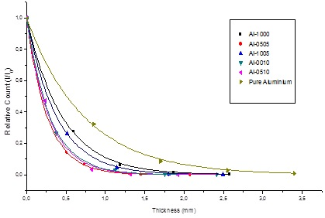
Figure 9. Relative intensity-thickness graphs for composite materials against Sr-90 beta source.
3. Results and Discussion
The experimental results of composite materials for the gamma radioisotopes Am-241, Cs-137 and Co-60 are listed in Table 2.
Table 2. Linear attenuation coefficient (μ) and half value thickness (HVT) of materials against Am 241, Cs-137 and Co-60 gamma sources.
Material Code | Am-241 |  | Cs-137 |  | Co-60
Material Code | μ (cm⁻¹) | HVT (cm) | μ (cm⁻¹) | HVT (cm) | μ (cm⁻¹) | HVT (cm)
Al-0510 | 2,124 ± 0.014 | 0,326 ± 0.002 | 0,279 ± 0.002 | 0,326 ± 0.017 | 0,207 ± 0.003 | 0,326 ± 0.044
Al-1005 | 1,326 ± 0.011 | 0,523 ± 0.004 | 0,235 ± 0.002 | 0,523 ± 0.024 | 0,174 ± 0.001 | 0,523 ± 0.033
Al-1000 | 0,701 ± 0.005 | 0,989 ± 0.007 | 0,193 ± 0.001 | 0,989 ± 0.024 | 0,147 ± 0.002 | 0,989 ± 0.051
Al-0010 | 2,208 ± 0.002 | 0,314 ± 0.000 | 0,284 ± 0.005 | 0,314 ± 0.044 | 0,212 ± 0.001 | 0,314 ± 0.022
Al-0505 | 1,368 ± 0.013 | 0,507 ± 0.005 | 0,239 ± 0.002 | 0,507 ± 0.024 | 0,177 ± 0.002 | 0,507 ± 0.055

Theoretical calculations were performed using the internationally recognised XCOM software to calculate theoretical gamma mass attenuation coefficients. These theoretical gamma mass attenuation coefficients calculated for the composites were compared with the theoretical values calculated by the XCOM software and are shown in Table 3, Table 4 and Table 5.

Table 3. Experimental and theoretical mass attenuation coefficients agaisnt Am-241 gama source.
Material  Code | Am-241
Material  Code | μ_{m} (cm²/g) x10⁻¹  Experimental | μ_{m} (cm²/g)x10⁻¹  Theoretical (XCOM) | Difference  (%)
Al-0510 | 5,820 | 5,938 | 2,0
Al-1005 | 4,218 | 4,271 | 1,2
Al-1000 | 2,673 | 2,662 | 0,4
Al-0010 | 5,941 | 5,996 | 0,9
Al-0505 | 4,278 | 4,326 | 1,1
Table 4. Experimental and theoretical mass attenuation coefficients agaisnt Cs-137 gama source.
Material  Code | Cs-137
Material  Code | μ_{m} (cm²/g) x10⁻²  Experimental | μ_{m} (cm²/g)x10⁻²  Theoretical (XCOM) | Difference  (%)
Al-0510 | 7,631 | 7,674 | 0,6
Al-1005 | 7,471 | 7,555 | 1,1
Al-1000 | 7,358 | 7,446 | 1,2
Al-0010 | 7,631 | 7,684 | 0,7
Al-0505 | 7,481 | 7,565 | 1,1
Table 5. Experimental and theoretical mass attenuation coefficients agaisnt Co-60 gama source.
Material  Code | Co-60
Material  Code | μ_{m} (cm²/g) x10⁻²  Experimental | μ_{m} (cm²/g) x10⁻²  Theoretical (XCOM) | Difference  (%)
Al-0510 | 5,661 | 5,744 | 1,4
Al-1005 | 5,521 | 5,728 | 3,6
Al-1000 | 5,596 | 5,719 | 2,2
Al-0010 | 5,715 | 5,751 | 0,6
Al-0505 | 5,526 | 5,735 | 3,6
When the experimental values obtained from gamma transmission experiments were examined, increasing the amount of tungsten carbide in the composite material increased the linear and mass attenuation coefficient values. The theoretical mass attenuation coefficients obtained from the XCOM programme were found to be close to the experimental results.
Table 6 shows the data, i.e. macroscopic cross section, linear attenuation coefficient values and HVT values obtained from neutron experiments.
Table 6. Macroscopic cross section values (Σ_{T}) and linear attenuation coefficient (μ) against to Pu-Be neutron source and Sr-90 beta source and half value thickness (HVT) of materials.
Material  Code | Pu-Be |  | Sr-90
Material  Code | Σ_{T} (cm⁻¹) | HVT (cm) | μ (mm⁻¹) | HVT (mm)
Al-0510 | 0,280 ± 0.009 | 2,478 ± 0.084 | 4,305 ± 0.034 | 0,161 ± 0.005
Al-1005 | 0,372 ± 0.014 | 1,862 ± 0.092 | 3,138 ± 0.033 | 0,221 ± 0.003
Al-1000 | 0,344 ± 0.016 | 2,013 ± 0.071 | 2,304 ± 0.026 | 0,301 ± 0.004
Al-0010 | 0,133 ± 0.006 | 5,208 ± 0.230 | 4,047 ± 0.042 | 0,171 ± 0.001
Al-0505 | 0,251 ± 0.012 | 2,760 ± 0.128 | 2,876 ± 0.138 | 0,241 ± 0.002
Pure Aluminum | - | - | 1,416 ± 0.025 | 0,490 ± 0.009
The neutron shielding effectiveness of the composite was found to increase with the addition of boron carbide, as demonstrated in the neutron experiment. It was observed that an increase in the quantity of tungsten carbide resulted in a reduction in the degree of improvement in neutron shielding effectiveness. Furthermore, the incorporation of greater quantities of tungsten carbide and boron carbide into the composite material resulted in enhanced beta shielding effectiveness.
The shielding effectiveness of the composite material in a mixed radiation field was evaluated, and the highest HVL values obtained between different types of radiation are presented in Table 7. A comparison of the lead element with the highest HVL values is presented in Figure 10.
Tablo 7. HVL values composite materials.
Material Code | Am-241  HVL (cm) | Cs-137  HVL (cm) | Co-60  HVL (cm) | Beta  HVL (mm) | Neutron  HVL (cm) | Gamma, Neutron and Beta  HVL (cm)
Al-0510 | 0,326 ± 0,001 | 2,489 ± 0,009 | 3,355 ± 0,022 | 0,161 ± 0,003 | 2,478 ± 0,042 | 3,355 ± 0,022
Al-1005 | 0,523 ± 0,002 | 2,951 ± 0,012 | 3,993 ± 0,017 | 0,221 ± 0,003 | 1,862 ± 0,036 | 3,993 ± 0,017
Al-1000 | 0,989 ± 0,004 | 3,593 ± 0,012 | 4,725 ± 0,026 | 0,301 ± 0,002 | 2,013 ± 0,046 | 4,725 ± 0,026
Al-0010 | 0,314 ± 0,001 | 2,444 ± 0,022 | 3,263 ± 0,011 | 0,171 ± 0,001 | 5,208 ± 0,115 | 5,208 ± 0,115
Al-0505 | 0,507 ± 0,002 | 2,898 ± 0,011 | 3,923 ± 0,028 | 0,241 ± 0,001 | 2,760 ± 0,064 | 3,923 ± 0,028
The theoretical value of the macroscopic cross section and the value of the linear attenuation coefficient for neutron and beta radiation for lead material are given in Buyuk, 201l and Ram, 1982 respectively.

Figure 10. Density versus the highest HVL values of hybrid composite materials.
The experimental results of Al-0510 were analysed and found to be coded with the lowest HVL value of the composite material.
Figure 11 presents a plot of the highest HVL values against the density of materials in different types of radiation sources. Consequently, the most efficacious material for shielding against a range of radiation types has been subjected to investigation.

Figure 11. Density versus the highest HVL values of hybrid composite materials.
- Conclusion

The principal objective of this study is to assess the shielding efficiencies of aluminum-boron carbide-tungsten carbide composite materials with varying compositions against gamma, beta and neutron radiation. The effectiveness of a material as a shield against different types of radiation can be altered by modifying its additives. Consequently, the most appropriate material to be used in the presence of mixed radiation was identified and evaluated in comparison with the conventional lead element. In the field of space research and nuclear power reactors, the use of a single composite material leads both needed less volume and shield the primer from high-energy cosmic radiation and secondary radiation resulting from the interaction of cosmic radiation with the shielding material. Furthermore, the low density of the shielding material is of significance in terms of reducing the cost in space missions. The Al-0510, when compared to other composite materials in this study, has been found to exhibit enhanced effectiveness in shielding against a range of mixed radiation types, as well as a lower density value. It is therefore proposed that this material can be effectively used for shielding purposes in conditions where different types of radiation are present.

Acknowledgement
I would like to thank Prof.Dr. Hüseyin Çimenoğlu, faculty member of the Department of Chemistry & Metallurgy at Istanbul Technical University, for his contributions to this publication.
References
[1] Glasstone,S. and Sesonske, A., 1967 : Nuclear Reactor Engineering, Princeton, New Jersey.
[2] Maskewitz, B. F., Trubey, D. K. and Roussin, R. W., 1974 : Materials Information in the Radiation Shielding Information Center, Radiation Shielding Information Cente Oak Ridge National Laboratory Oak Ridge, Tennessee.
[3] Cohen, M.M., 2004 : Carbon Radiation Shielding for the Habot Mobile Lunar Base, Advanced Projects Branch, Space Projects Division, NASA-Ames Research Center, 34th International Conference on Environmental Systems (ICES) Colorado Springs, Colorado.
[4] Sztejnberg, M., Xiao, S., Satvat, N., Limón, F., Hopkins, J. and Jevremovic,T., 2006: Radiation Shielding Aspects for Long Manned Mission to Space– Criteria, Survey Study, and Preliminary Model –, Nuclear Technology & Radiation Protection – 2/2006 , 1451-3994, 21, 2, pp. 47-66.
[5] Chen,S. , Bourham, M. and Rabiei, A., 2014 : Novellight-weight Materials for Shielding Gamma ray, Radiation Physics and Chemistry 96, 27-28.
[6] Singh, P. V. and Badiger, N.M., 2014: Gamma ray and Neutron Shielding Properties of Some Alloy Materials, Annals of Nuclear Energy 64, 301-302.
[7] Akkas, A., Tugrul, A. B., Buyuk B., Addemir, A.O., Marsoglu, M. and Agacan B., 2015: Shielding Effect of Boron Carbide Aluminum Metal Matrix Composite against Gamma and Neutron Radiation, Acta Physica Polonica A, Vol.128 (Doi: 10.12693/APhysPolA.128.B-176).
[8] Akkas, A., Tugrul, A. B., Buyuk B., Addemir, A.O., Marsoglu, M. and Agacan B.,2015. Radiation Shielding Effect of Boron Carbide Aluminum Metal Matrix Composites, Acta Physica Polonica A,Vol.127 (Doi: 10.12693/APhysPolA.127.947).
[9] Matkovich, V.I., 1977 : Boron and Refractory Borides, Springer, P:2., New York.
[10] Kurlov, A. and Aleksandr, G. I., 2013 : Tungsten Carbides Structure, Properties and Application in Hardmetals, Springer, P:2., New York.
[11] M.J. Berger, J.H. Hubbell, NBSIR 87 ‘‘XCOM: Photon Cross sections on a personal computer” web version 1.2, http://physics.nist.gov/xcomv (1999).
[12] Knoll, G. 2002: Radiaiton Detection and Measurement, University of Michigan, John Wiley&Sons, Inc.
[13] Gordus A.A.(1967). Quantitative Non-destructive Neutron Activation Analysis of Silver in Coins. Archaeometry, 10(1), pp78-86.
[14] Ram, N., Rao, S. and Mehta, M.K., 1982 : Mass absorbtion coefficient and range of beta particles in Be,Al,Cu, Ag and Pb, Prahana Vol.18, No:2 , 121-126, India.

